## 1)Write an R Function to initialize a data frame for 10 people with columns as name and

height (in cm). Use for loop to convert the height into the meter.

f<-function(name,height)

{

data<-data.frame(name,height)

return (data)

}

name<-scan(what="char")

height<-scan()

data<-f(name,height)

d<-data

newh<-c()

for(i in 1:10)

{

newh=c(newh,data[i,2]/100)

}

data<-data.frame(name,height=newh)

print("Height in cm")

print(d)

print("Height in m")

print(data)

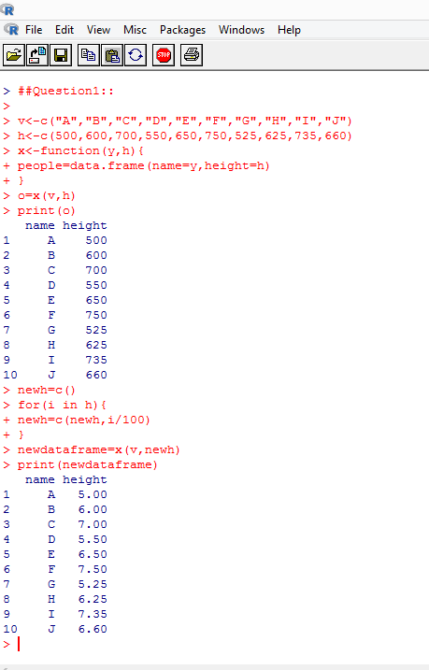

##Q2

myvector<-c(0.1,0.6,33.8,1.9,9.6,4.3,33.7,0.3,0.0,0.1)

mean(myvector)

sd(myvector)

for(i in seq_along(myvector))

{

if(myvector[i]==max(myvector))

{

print(paste("The highest rainfall is on day",i,sep=' '))

}

}

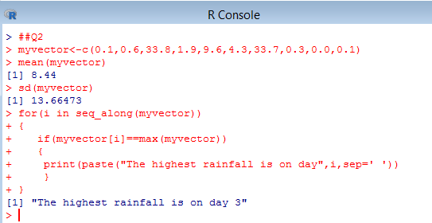

##Q3

x<-runif(100,0,1)

m<-matrix(x,10,10)

m

#(i)

rmean<-rowMeans(m)

rmean

colmean<-colMeans(m)

colmean

#(ii)

sum<-sum(diag(m))

sum

#(iii)

sd(m)

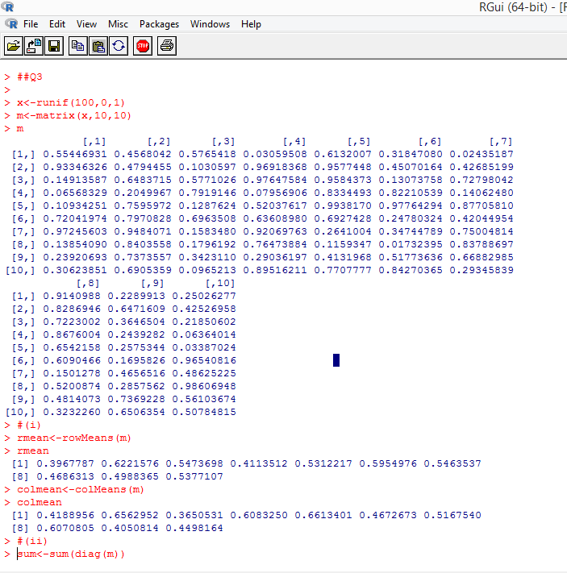

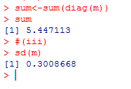

##Q4

P<-c("person_1","person_2","person_3","person_4","person_5","person_6","person_7","person_8")

I<-c(10000,14000,24000,43000,12323,13414,43212,36000)

low_risk=character(0)

high_risk=character(0)

for(i in 1:8)

{

if(I[i]<30000)

{

high_risk=c(high_risk,P[i])

}

else

{

low_risk=c(low_risk,P[i])

}

}

low_risk

high_risk

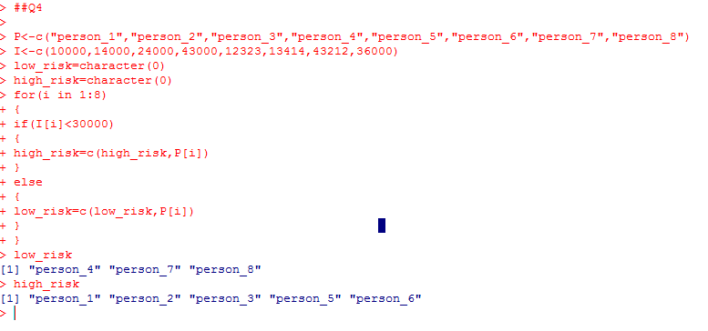

##Q5

X<-c(TRUE,FALSE,FALSE,TRUE)

Y<-c(FALSE,TRUE,FALSE,TRUE)

print(X & Y)

j<-TRUE

for(i in X)

{

j<-j||i

}

print(j)

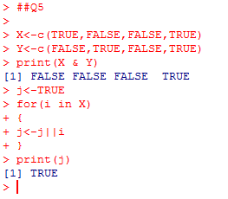

##Q6

data(iris)

head(iris,3)

dim(iris)

summary(iris)

names(iris)

x<-iris

class(x)

x[3,4]

x[3,1:4]

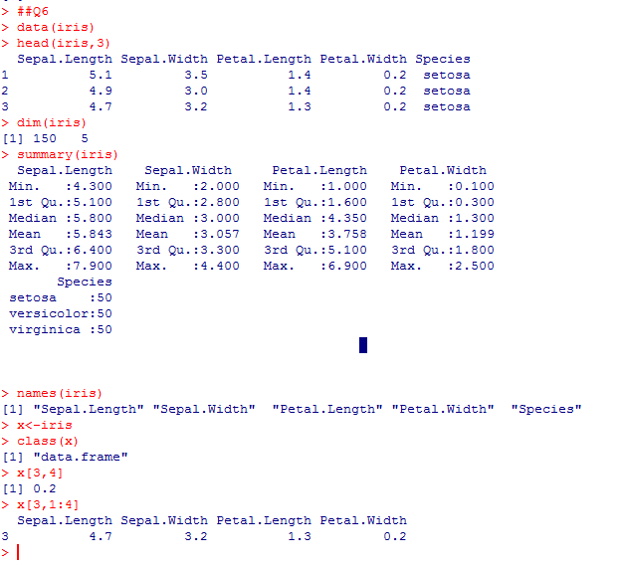

##Q7

AMOUNT<-c(90,50,100,40,20,38)

CHEMICAL<-c("c1","c2","c3","c4","c5","c6")

colors<-c("green","red","blue","orange","pink","yellow")

pie(AMOUNT,label=CHEMICAL,col=colors,init.angle=180)

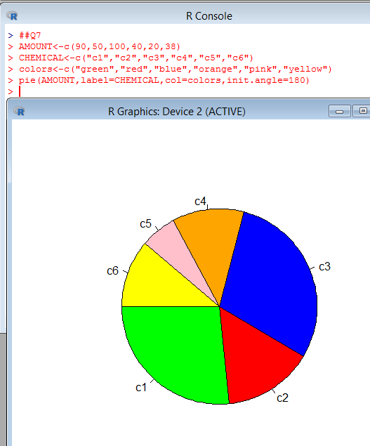

##Q10

a=0

b=0

for(i in 1:3)

{

a=a+1

for(j in 1:4)

{

b=b+1

if(j==2)

{

break

}

}

}

print(a)

print(b)

